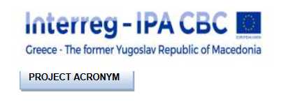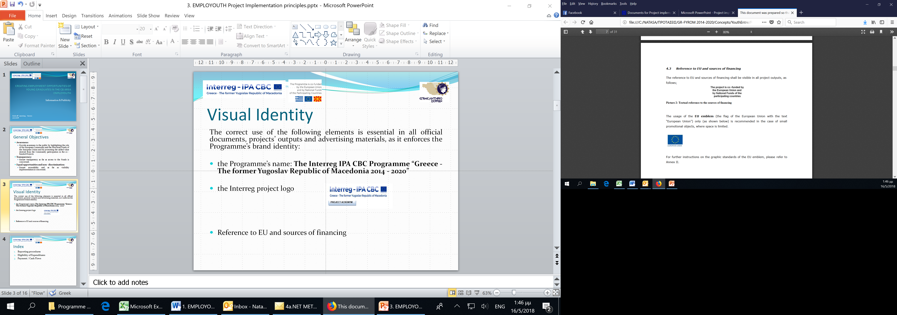
Annex TD 1
Simplified tender dossiers for service, supply and works – SINGLE TENDER
Name and address of the Contracting Authority:
Public Communal Enterprise “ Proleter”
St. Obikolna 22, 7310 Resen
The Republic of North Macedonia
Title of the tender:Services for preparation “As Built”documentationfor the renovation of water pipeline
Reference number: CN1-S.O 2.3-SC011/TD5

1. INFORMATION ON SUBMISSION OF THE TENDERS
The subject of this tender is:
- Implementation of services as indicated in the technical information in the point 2 of these information;

The main result to be achieved under this Contract:
- the Contractor shall prepare the final “As Built”documentationfor the renovation of water pipeline which shall include system technical description drawings, equipment and material lists. Contractor shall prepare the relevant “As Built” documents in digital files in DWG format and the corresponding technical descriptions, calculations, reports etc. shall be processed in MS WORD and / or EXCEL format.

Deadline for submission of the tenders:
The deadline for submission of tenders is 15 (day), April (month), 15.04.2021 at 12:00 hours, local time. Any tender received after this deadline will be automatically rejected.
* - The tenderer should have minimum 7 days from the date of launching of the procurement procedure for preparation of the offer (excluding the day of publishing and the date of submission deadline).

** - The Contracting Authority is obliged to provide answer to all questions received no latter then 3 days before the deadline and has to publish them on the same web sites where the tender was published.

Address and methods for submission of the tenders:
The tenderers will submit their tenders using the standard submission form available in the Part B – Format of Technical offer and the Part C – Format of Financial offer of the tender dossier. The tender will be submitted in 1 original. Any tenders not using the prescribed form might be rejected by the Contracting Authority.
In addition to the offer the tenderer is required to provide the following supporting documentation:
- Copy of legal registration,
- List of key experts,
- List of similar As-Build documentation,
- CV of authorized person, copy of authorizations and copy of diplomas or employers’ certificates or referances proving the professional experience
If delivery by post:
The tenders will be submitted via post/currier, containing the following information:
- | Name and address of the tenderer
- | Title of the tender: Services for preparation “As Built”documentation for the renovation of water pipeline
- | Reference number :CN1-S.O 2.3-SC011/TD5  - The words: ‘’Not to be opened before the tender opening session’’ and ”Да не се отвaра пред јавно отвoрање на понудите”

Tenders must be submitted using double envelope system, in an outer parcel or envelope containing two separate, sealed envelopes, one bearing the words "Technical offer”- part B and "Financial offer" - Part C.
The tenders will be submitted in person, by post or courier service to the following address:
Public Communal Enterprise “Proleter”
St. ‘’Obikolna’’ 22, 7310 Resen
The Republic of North Macedonia

Working hours: 09.00 – 14.00 CET
The tenderers are reminded that in order to be eligible the tenders need to be received by the Contracting Authority by the deadline indicated above.



2. TECHNICAL INFORMATION
The tenderers are required to provide services as indicated below.
In the tenderer’s technical offer, the tenderers will indicated more details on the deliveries, referring back to the below table.

No. | Title of item/activity | Description | Required time frame | Required inputs, if applicable
1.1 | preparation of “As -Built” documentation for the renovation of water pipeline | - structural technical inspection of the existing overall facilities,  - preparation and planning of specification for the renovation work of the water pipeline with length of 360m | 7 days | Civil engineer
1.2

Description of expected outputs / results to be achieved
The tenderer should deliver the relevant “As Built” documents in digital files in DWG format and the corresponding technical descriptions, calculations, reports etc. processed in MS WORD and / or EXCEL formatat the premises of the Public Communal Enterprise “Pelister”,Obikolna 22, 7310 Resen.
Required inputs
Key expert: Civil engineer
- Authorised Civil Engineer according to the Macedonian legislation (Authorization “A” for Civil Engineering issued by Chamber of certified architects and certified engineers of North Macedonia)
- The designer must be in the field of Hydrotechnics with a specialization in water supply system (M.Sc. or PhD) with knowledge and proven professional experience as responsible designer (minimum 3 As – Built documentation) within the period of the last 3 years from the submission deadline
If necessary the tenderer can name two or more persons.
Cost for backstopping and support staff, as needed, are considered to be included in the financial offer of the tenderer.
Required time frame
7 days after signing the Contract by both parties
3. FINANCIAL INFORMATION
The tenderes are reminded that the maximum available value of the contract is 3.000,00 EUR (VAT excluded)
The Financial offer must be presented as an amount in EUR and must be submitted using the template for the global-price version of PART C: FORMAT OF FINANCIAL OFFER.

[In case of foreign suppliers, payments shall be made in EURO.In case of domestic supplier payments shall be made in MKD.In case the contract is concluded in EURO, and payments are made in national currency, applicable exchange rate must be InforEuro exchange rate of the month and year corresponding to the deadline for submitting applications. The invoices have to be issued through the system of Public Revenue Office of the Republic of North Macedonia as the Project SmartWaaterSave is excluded from the tax system.]

Award criteria:
In case more than one offer received: best value for money, weighting 80% technical quality, 20% price.

Evaluation criteria for technical offer:
- Organization and methodology: 60 points
- Proposed inputs: 30 points
- Time frame: 10 points
TOTAL: 100 points

In case one offer received: the Contracting Authority shall check whether the offer is administratively, technically and financially compliant with the requirements set by this tender documentation.

4. ADDITIONAL INFORMATION
The unsuccessful/successful tenderers will be informed of the results of the evaluation procedure in written form.
The estimated time of response to the tenderers is 7 days from the deadline for submission of tenders.

